Name: Aspeta Divakar

Trainer Name: Harshee Pitroda

Course Name: Python And ML

Date:3/06/2022

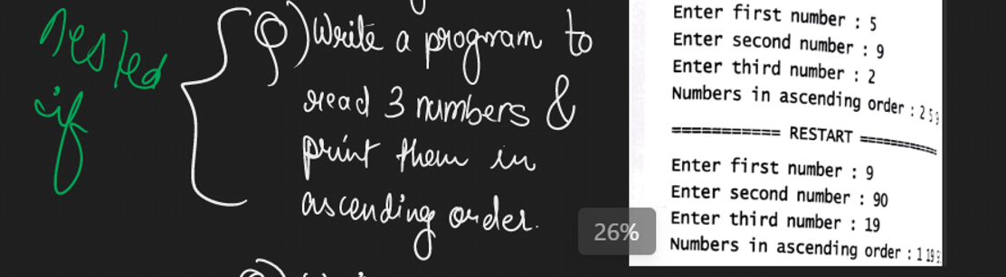

Code:

a=int(input('Enter first number:'))

b=int(input('Enter second number:'))

c=int(input('Enter third number:'))

print('Numbers in ascending order:',sep=' ')

if a<b and a<c:

print(a,end=' ')

if b<c:

print(b,c,sep=' ')

else:

print(c,b,sep=' ')

elif b<c and b<a:

print(b,end=' ')

if c<a:

print(c,a,sep=' ')

else:

print(a,c,sep=' ')

else:

if c<a and c<b:

print(c,end=' ')

if a<b:

print(a,b,sep=' ')

else:

print(b,a,sep=' ')

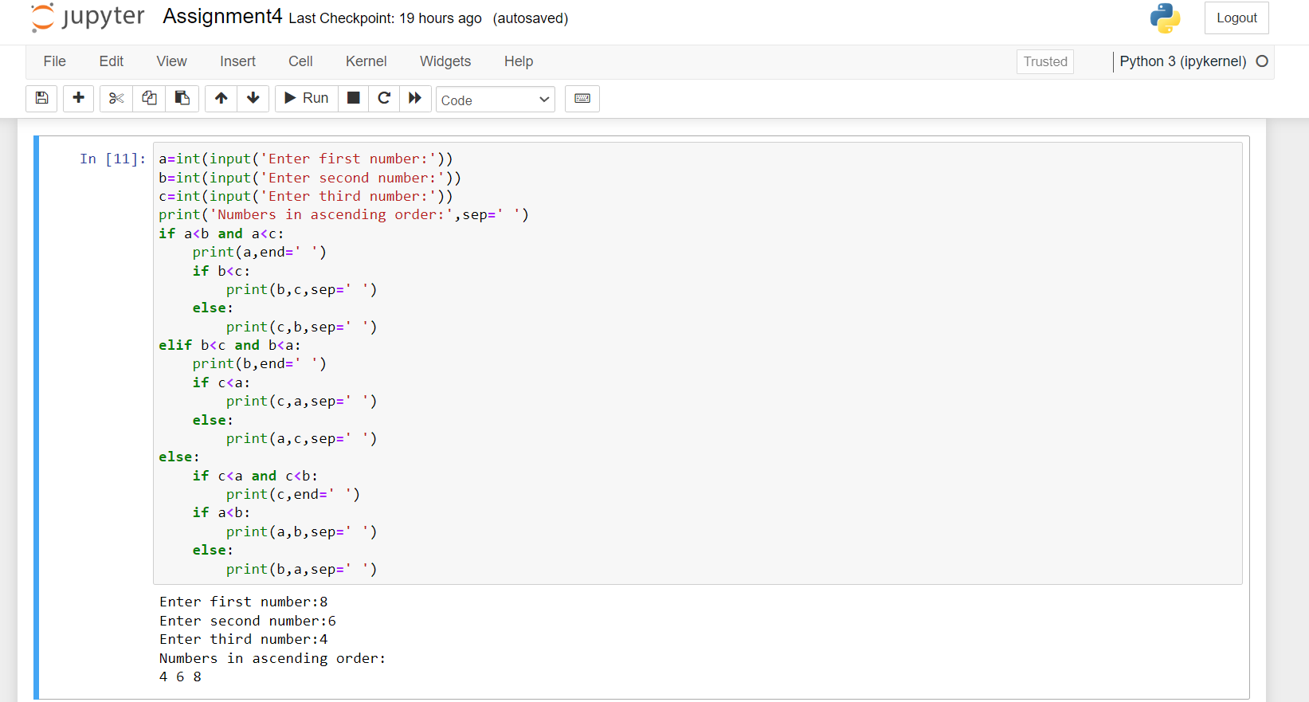

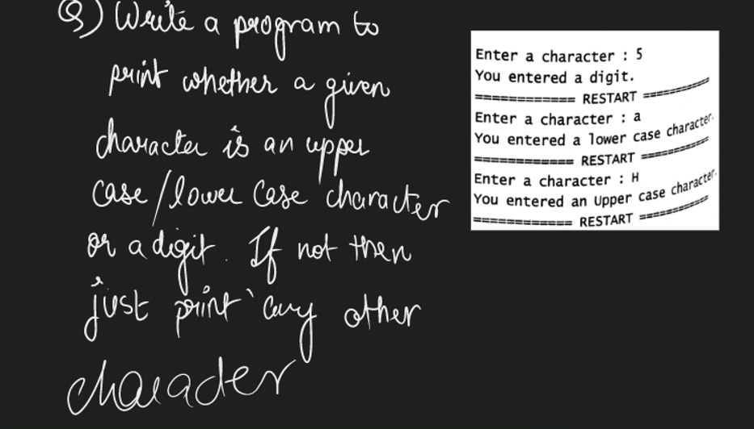

Code:

a=input('Enter a character:')

if a.isdigit()==True:

print('You entered a digit')

elif a.islower()==True:

print('Your entered a lower case character')

elif a.isupper()==True:

print('Your entered a upper case character')

else:

print('Any other character')

